**CHAPTER 2**

**2.1 Introduction**

A **literature survey** in a project report represents the study done to assist in the completion of a project. A literature survey also describes a survey of the previous existing material on the topic of the report. The focus of a literature survey on the following and in this order:

* Existing theories on a topic with universal acceptance across the board
* Books on the subject acting as a reference for the concepts that project uses whether they are specific or generic.
* Current research concerning the field of the project from the oldest to the latest. Research papers might be a reference for theories nut most cases require a critical comparison to establish the purpose of the project and improvement
* You may also include another project report and what helped you
* Challenges for the project and by ongoing work if it is available

Literature surveys provide brief overviews or a summary of the current research on topics. The structure written requires to be in a way that it seemed logical. It needs to chronologically represent a development of the ideas in the field that is being researched. The length of a literature survey depends much on whether the purpose of the project report is to complete a college assignment or submitting for journal publication. It can review a few research papers on a topic or be a full-length discussion on the significant work in the field until that date.

**Literature surveys** are used in ensuring that the used experiments, methodologies and experiments offer reliability and validity in the research being conducted. The surveys need to show essential content avoiding much interpretation. One’s opinions and conclusions require to be separated from the content in the cited sources.

**2.2 Literature Survey**

**1. Recent Advances in Convolutional Neural Networks:Jiuxiang Gua,, Zhenhua Wangb, , Jason Kuenb , Lianyang Mab , Amir Shahroudyb , Bing Shuaib , Ting Liub , Xingxing Wangb , Li Wangb , Gang Wangb , Jianfei Caic , Tsuhan Chenc**

In the last few years, deep learning has led to very good performance on a variety of problems, such as visual recognition, speech recognition and natural language processing. Among different types of deep neural networks, convolutional neural networks have been most extensively studied. Leveraging on the rapid growth in the amount of the annotated data and the great improvements in the strengths of graphics processor units, the research on convolutional neural networks has been emerged swiftly and achieved state of-the-art results on various tasks. In this paper, they provide a broad survey of the recent advances in convolutional neural networks. idealize the improvements of CNN on different aspects, including layer design, activation function, loss function, regularization, optimization and fast computation. Besides, we also introduce various applications of convolutional neural networks in computer vision, speech and natural language processing.

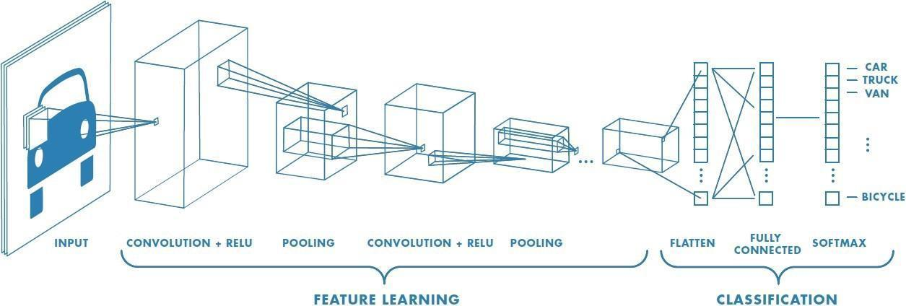

Fig. Convolution Neural Network

**2.** **Transfer Learning, Chuanqi Tan , Fuchun Sun , Tao Kong  , Wenchang Zhang , Chao Yang , and Chunfang Liu**

As a new classification platform, deep learning has recently received increasing attention from researchers and has been successfully applied to many domains. In

some domains, like bioinformatics and robotics, it is very difficult to construct a large-scale well-annotated dataset due to the expense of data acquisition and costly annotation, which limits its development. Transfer learning relaxes the hypothesis that the training data must be independent and identically distributed (i.i.d.) with the test data, which motivates us to use transfer learning to solve the problem of insufficient training data. This survey focuses on reviewing the current research of transfer learning by using deep neural network and its applications. We defined deep transfer learning, category and review the recent research works based on the techniques used in deep transfer learning.

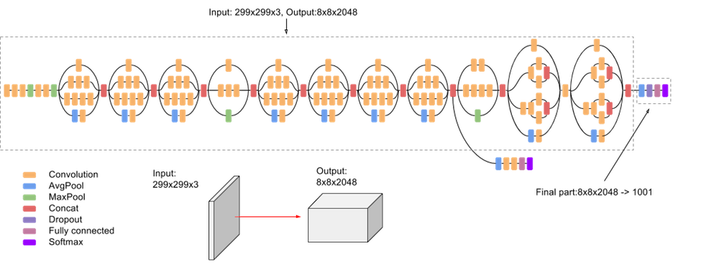

Fig.Transfer Learning Methodology

**3. Faster R-CNN: Towards Real-Time Object Detection with Region Proposal Networks Shaoqing Ren∗ Kaiming He Ross Girshick Jian Sun**

This paper proposes a Fast Region-based Convolutional Network method (Fast R-CNN) for object detection. Fast R-CNN builds on previous work to efficiently classify object proposals using deep convolutional networks. Compared to previous work, Fast R-CNN employs several innovations to improve training and testing speed while also increasing detection accuracy. Fast R-CNN trains the very deep VGG16 network 9x faster than R-CNN, is 213x faster at test-time, and achieves a higher mAP on PASCAL VOC 2012. Compared to SPPnet, Fast R-CNN trains VGG16 3x faster, tests 10x faster, and is more accurate.

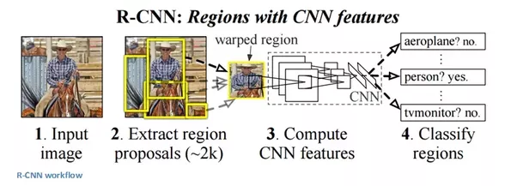

Fig. Fast Region-CNN

**4. SSD: Single Shot MultiBox Detector, Wei Liu,Dragomir Anguelov, Dumitru Erhan, Christian Szegedy, Scott Reed, Cheng-Yang Fu, Alexander C.Berg**

https://arxiv.org/pdf/1512.02325.pdf

SSD is designed for object detection in real-time. Faster R-CNN uses a region proposal network to create boundary boxes and utilizes those boxes to classify objects. While it is considered the start-of-the-art in accuracy, the whole process runs at 7 frames per second. Far below what a real-time processing needs. SSD speeds up the process by eliminating the need of the region proposal network. To recover the drop in accuracy, SSD applies a few improvements including multi-scale features and default boxes. These improvements allow SSD to match the Faster R-CNN’s accuracy using lower resolution images, which further pushes the speed higher. According to the following comparison, it achieves the real-time processing speed and even beats the accuracy of the Faster R-CNN. (Accuracy is measured as the mean average precision mAP: the precision of the predictions.)

**5. You only look once (YOLO),Wei Liu1, Dragomir Anguelov, Dumitru Erhan, Christian Szegedy, Scott Reed , Cheng-Yang Fu1 , Alexander C. Berg**

# YOLO (You Only Look Once) uses deep learning and convolutional neural networks (CNN) for object detection, it stands out from its “competitors” because, as the name indicates it only needs to “see” each image once. This allows YOLO to be one of the fastest detection algorithms (naturally sacrificing some accuracy). Thanks to this swiftness YOLO can detect objects in real time (up to 30 FPS).To carry out the detection, the image is divided in a grid of SxS (left image). Each one of the cells will predict N possible “bounding boxes” and the level of certainty (or probability) of each one of them (image at the center), this means SxSxN boxes are calculated. The vast majority of these boxes will have a very low probability, that’s why the algorithm proceeds to delete the boxes that are below a certain threshold of minimum probability. The remaining boxes are passed through a “non-max suppression” that will eliminate possible duplicate objects and thus only leave the most exact of them .

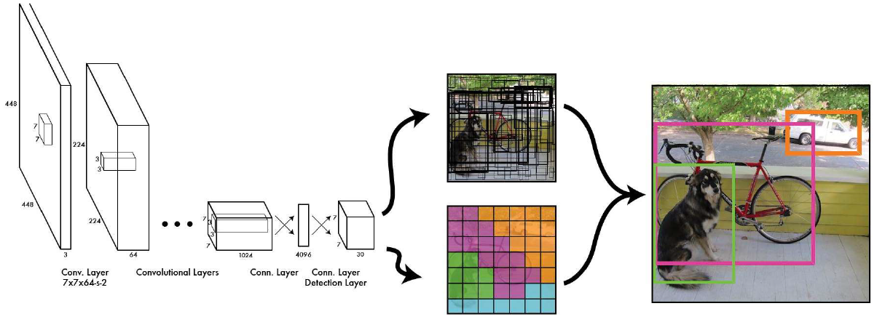

Fig. Yolo Object Detection

**2.3 METHODOLOGY**

* **Detect Design Patterns**

A Custom Vision Model trained to perform object recognition against HTML      hand drawn patterns is used to detect meaningful design elements of HTML and covert it into a HTML page.

* **Understand Handwritten Text**

Each Element is passed through Text Recognition Service to extract handwritten content.

* **Understand Structure**

The information of the detected objects and their objects and their position inside the image is fed to algorithm that generates underlying structure.

* **Build Front End**

A valid Front End is developed either a HTML code is generated or an XML code is generated with the actual HTML elements that were detected.

This is developed with a user interactive website where the user can use this feature of developing front end or the user can just use his whatsapp messenger to send a snap of the design and get the actual HTML website and code on his phone.This feature is implemented using Dilog Flow and Twilio.

**2.3 SUMMARY**

Literature Survey is known to provide the working knowledge about the state of a field or research topic. It will include many notes but without a real analysis or an opinion. The purpose of a literature survey is to decide easy of moving a research idea forward on what researchers have done and exciting avenues that it opens for investigation during future work in the field.

We are using object detection to identify the various html elements. For object detection we use Convolution Neural Network. Convolution Neural Network is a deep neural; network which has multiple hidden layer, an input layer and an output layer. The various CNN models are:

* Single Shot Detection (SSD)
* You Look Only Once (YOLO)
* Region based Convolution Neural Network (R-CNN)

We use transfer learning because training a model from scratch needs a large dataset and a high processor. So using transfer learning we train the pre trained model by just

changing the last layer to our required classes. In our project the html elements are the various classes which is the last layer of the model.